**San Dimas High School 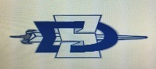 Saints Football 2016**

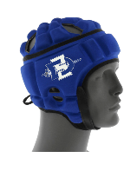  **HELMETS**

**Attention All Student Athletes Interested In Football**

**San Dimas Football prides itself on making safety its first priority. All student athletes participating in football must wear protective gear. Game helmets will be provided to all athletes, however it is recommended that a practice helmet be worn during practice, and during passing league tournaments.**

**Gamebreaker will be at SDHS March 1st during the incoming 8th grade parent night. Gamebreaker will properly fit helmets, answer any questions, and take orders. Please see the attached information sheet for more details.**

**We look forward to meeting all parents, and students on March 1. Stop by the Saints Football table for information packets, our season calendar, meet the coaches, and fill out a prospective player card.**

**Welcome to San Dimas High School. Go Saints!**